# Functional Decomposition Diagram

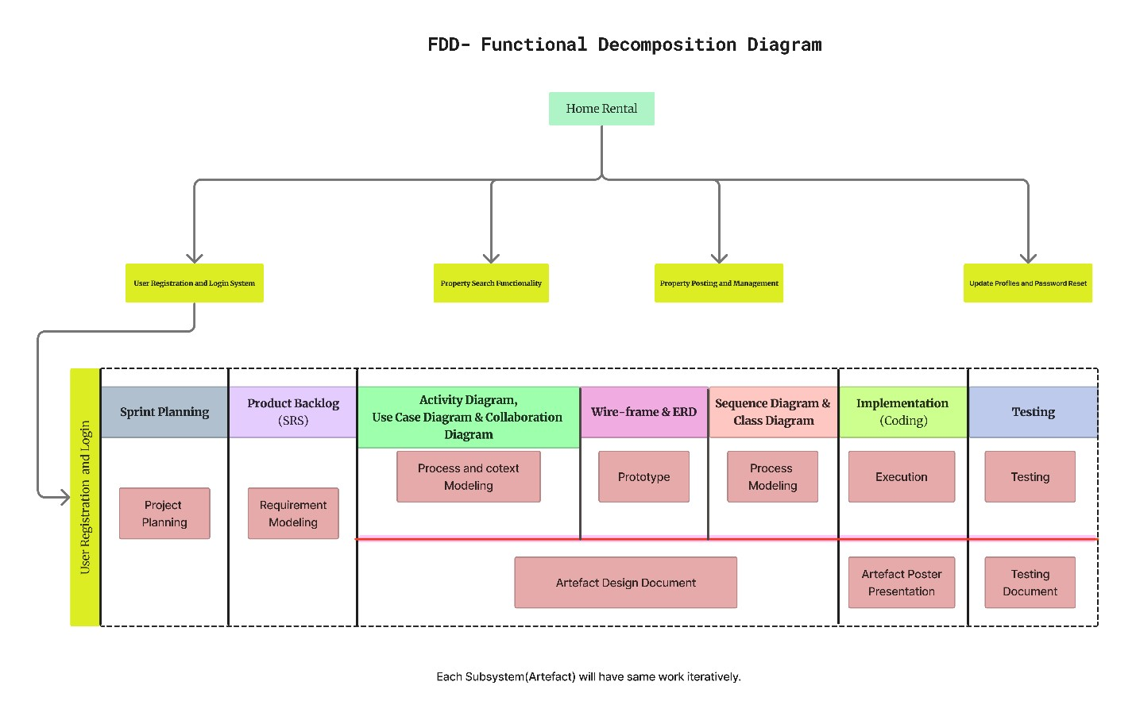

# SRS Document

Legend:



U

RL

-

F

-

1.0



Sub systems

URL

:

User Registration and Login System

PSF

:

Property Search

Functionality

P

PM

:

Property Posting and Management

UPP

:

Update Profiles and Password Reset



Types of Requirements:

F

:

Functional Requirements

NF

:

Non

-

Functional Requirements

UR

:

Usability Requirements



Numbering

## SRS Document for User Registration and Login System

|  |  |  |
| --- | --- | --- |
| Req code | Req.Desc | Use case |
| **URL-F-1.0** | The system shall allow customers to register themselves | Register user |
| **URL-NF-1.0** | The system shall encrypt registration data before sending to the server. | Security |
| **URL-UR-1.0** | On smaller devices, the header shall appear as a menu for medium better viewing and usability. | Better view |
| **URL-F-1.1** | The system shall allow registered users to log in. | User login |
| **URL-NF-1.1** | User password shall be combination of alphabets ,number and special character for enhanced security. | User password |
| **URL-UR-1.1** | The user and company registration forms shall be fully responsive and provide an optimal user experience on mobile devices. | Company registration |
| **URL-F-1.2** | The system shall provide a registration form for companies to create account. | Create account |
| **URL-F-1.3** | The system shall allow registered companies to login. | Company login |
| **URL-F-1.4** | The system shall allow addition of new users and companies by administrators. | Register new user |
| **URL-F-1.5** | The system shall provide a functionality for users and high companies to reset their password. | Reset password |
| **URL-F-2.0** | The system shall allow the admin to add and remove users. | Add and remove users |
| **URL-F-2.0** | The admin shall have access to a secure panel for user management. | Secure panel |

## SRS Document for Property Search Functionality (PSF)

|  |  |  |
| --- | --- | --- |
|  | | |
| **Req. Code** | **Req. Desc** | **Use case** |
| **PSF-F-1.0** | The System shall provide filters for property search. | Filter property |
| **PSF-F-1.1** | users Shall be able to search properties by location. | Search property |
| **PSF-F-1.2** | Users shall be able to search properties by property category. | Property category |
| **PSF-F-1.3** | Users shall be able to search properties by property type. | Property type |
| **PSF-F**  **2.0** | The System shall implement an advanced search algorithm to improve search accuracy and relevance. | Search algorithm |
| **PSF-NF 2.0** | The Search algorithm shall return results within 3 seconds under normal server load conditions. | Return result |
| **PSF-F-3.0** | The System shall display property search results in a user-friendly format. | User friendly format |
| **PSF-NF-3.0** | Property listings shall include detailed information such as property tittle, location, description and price. | Property listings |
| **PSF-UR-3.0** | Users shall have the search results shown in listing manner or other criteria. | Listing manner |

## SRS Document for Property Posting and Management (PPM)

|  |  |  |
| --- | --- | --- |
| **Req. Code** | **Req. Desc** | **Use case** |
| **PPM-F-1.0** | The System shall provide a form for property owners to post their properties. | Property form |
| **PPM-F-1.1** | Property owners shall be able to enter property details such as property title, description, price and location. | Property details |
| **PPM-NF-1.0** | The property post form shall enforce character limits and validate input data to prevent errors. | Character limits |
| **PPM-F-2.0** | The System shall display posted properties in a user-friendly format. | Display properties |
| **PPM-F-2.1** | Property listings shall include property title, location, description and price. | Property details |
| **PPM-UR-2.0** | Property listings shall be visually appealing and easy to navigate. | Easy navigate |
| **PPM-F-3.0** | The system shall provide tools for managing property bookings. | Managing property |
| **PPM-F-3.1** | Property owners shall receive a confirmation upon successful posting of their property. | Confirmation  property |
| **PPM-F-3.2** | Property owners shall have the ability to review and edit property details. | Edit and review property |
| **PPM-UR-3.0** | Property owners shall have the option to manage property bookings based on various criteria such as availability and price. | Property booking |

## SRS Document for Update Profiles and Password Reset (UPP)

|  |  |  |
| --- | --- | --- |
| Req code | Req.Desc | Use case |
| UPP-F-1.0 | Users shall able to update their profiles | Update profiles. |
| URL-NF-1.0 | User shall able to update their profiles information including their name and email. | User update. |
| URL-UR-1.0 | User shall be to upload and update their profile pictures. | Upload pictures |
| URL-F-1.1 | The system shall provide functionality for users and property owners to reset their passwords if forgotten. | Reset password |

# ERD Diagram

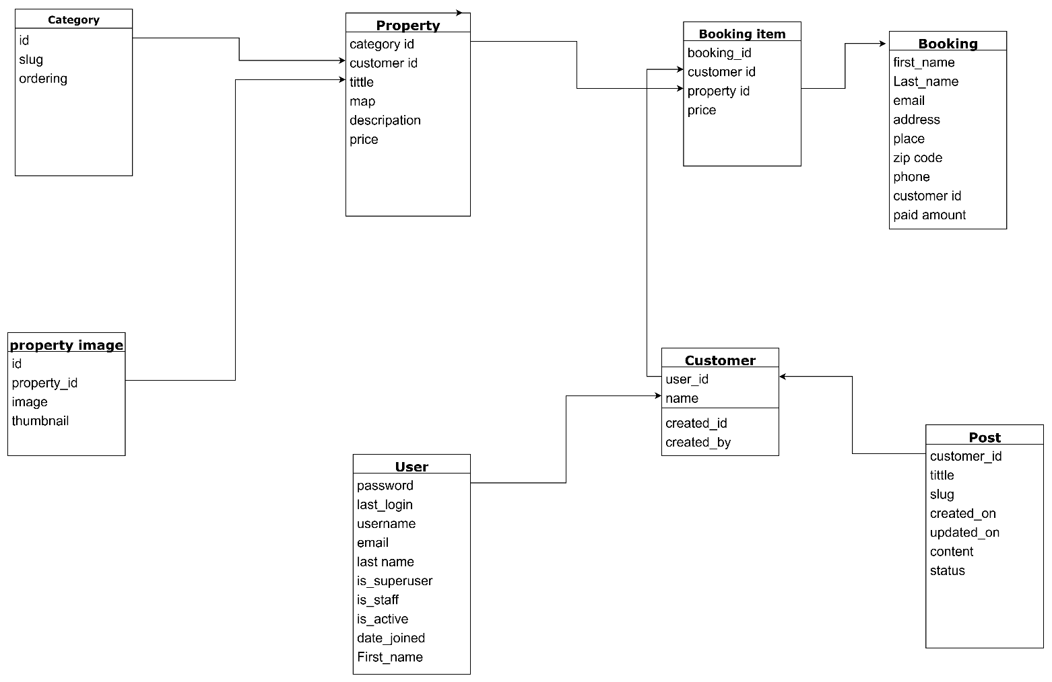

# Sequence Diagram

## View Blog

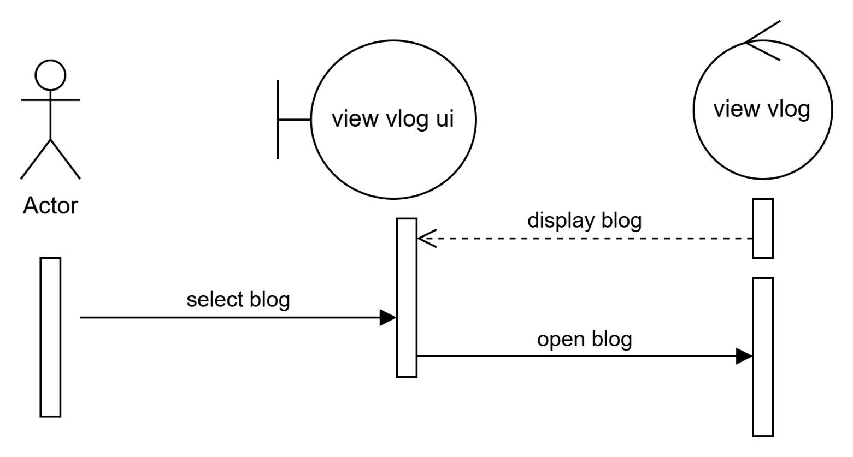

## Registration

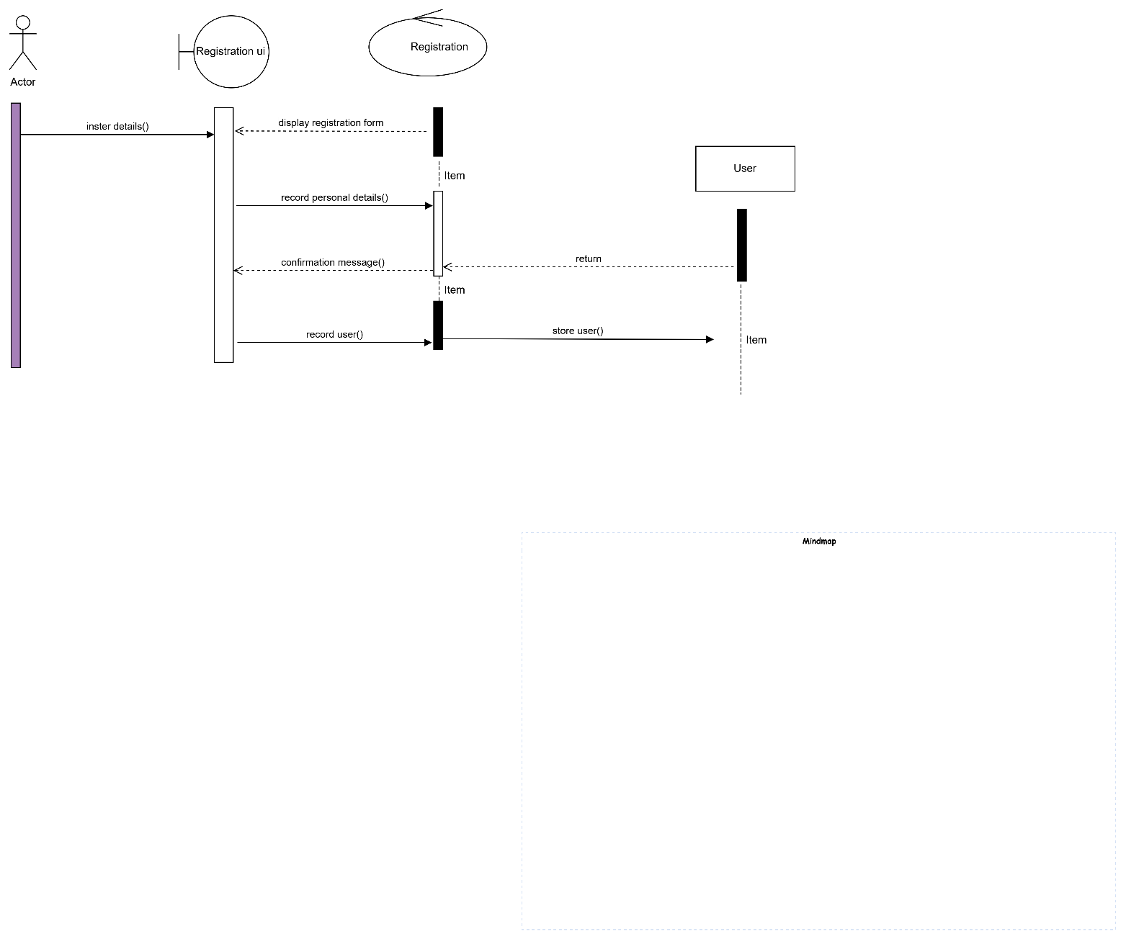

## 

## Login

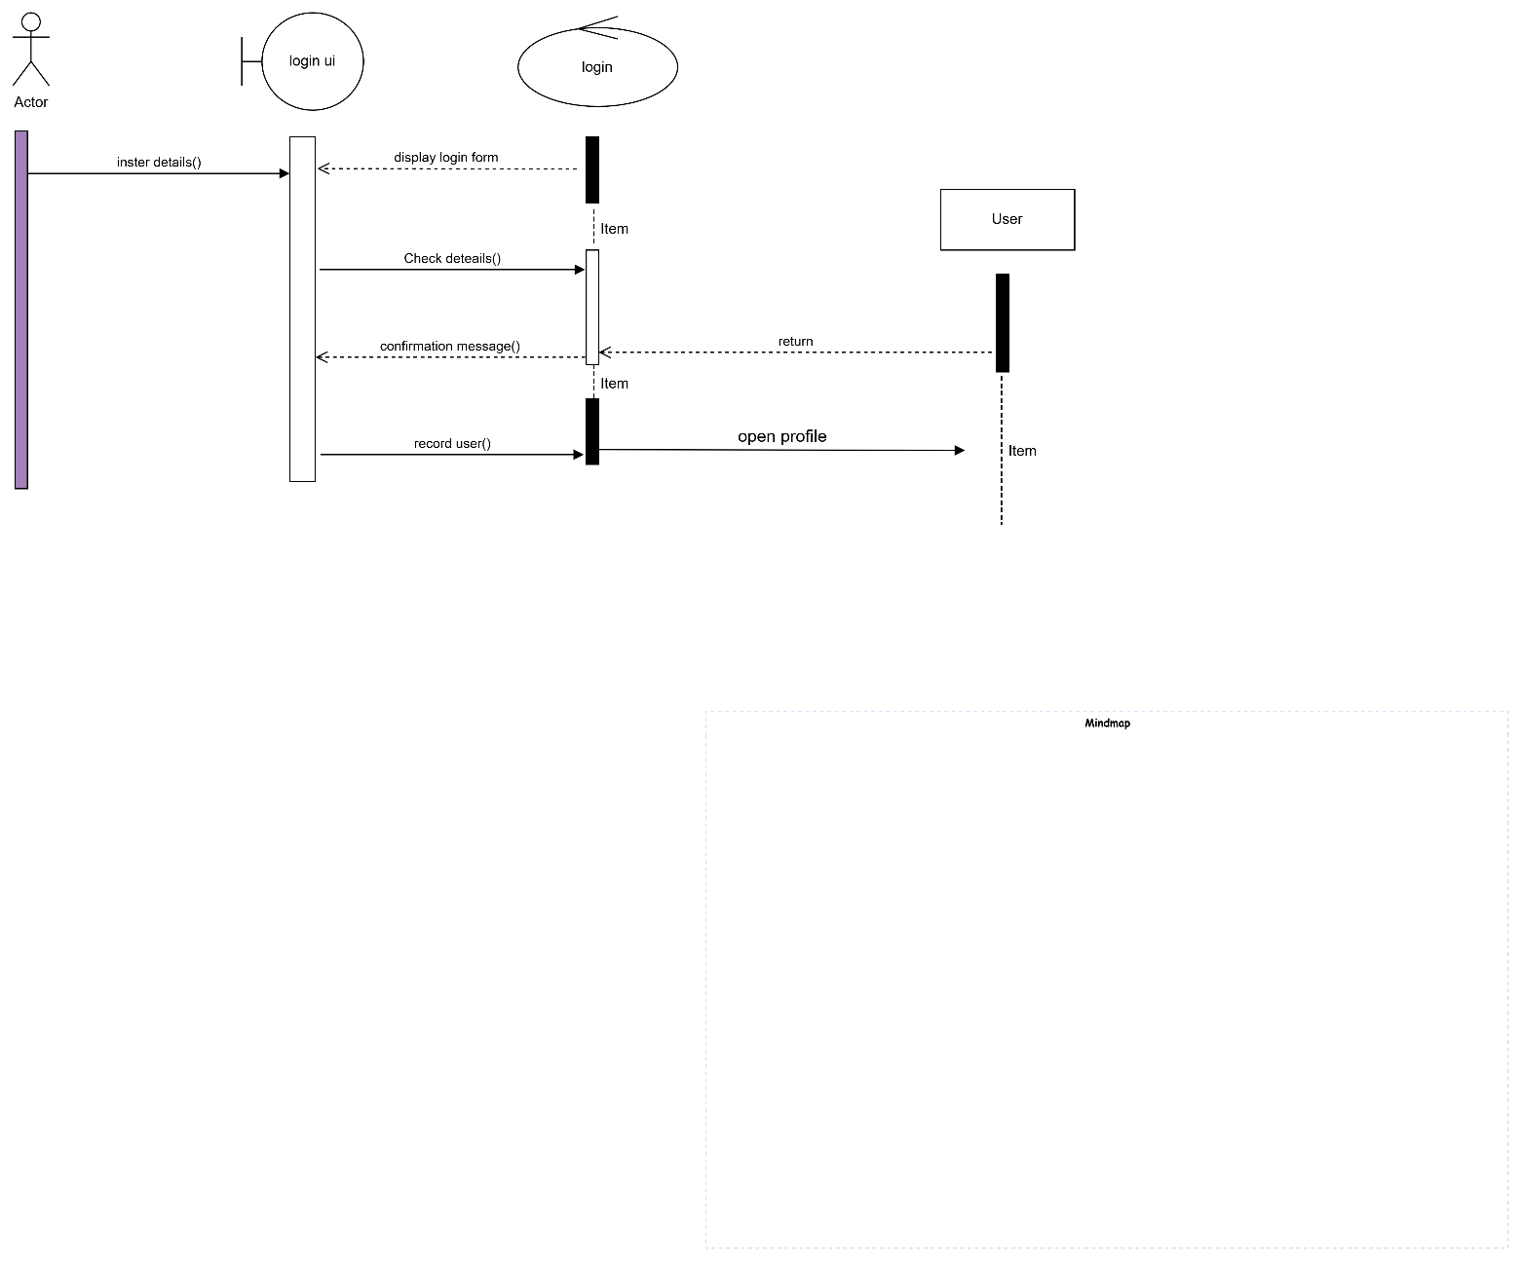

## Post Property

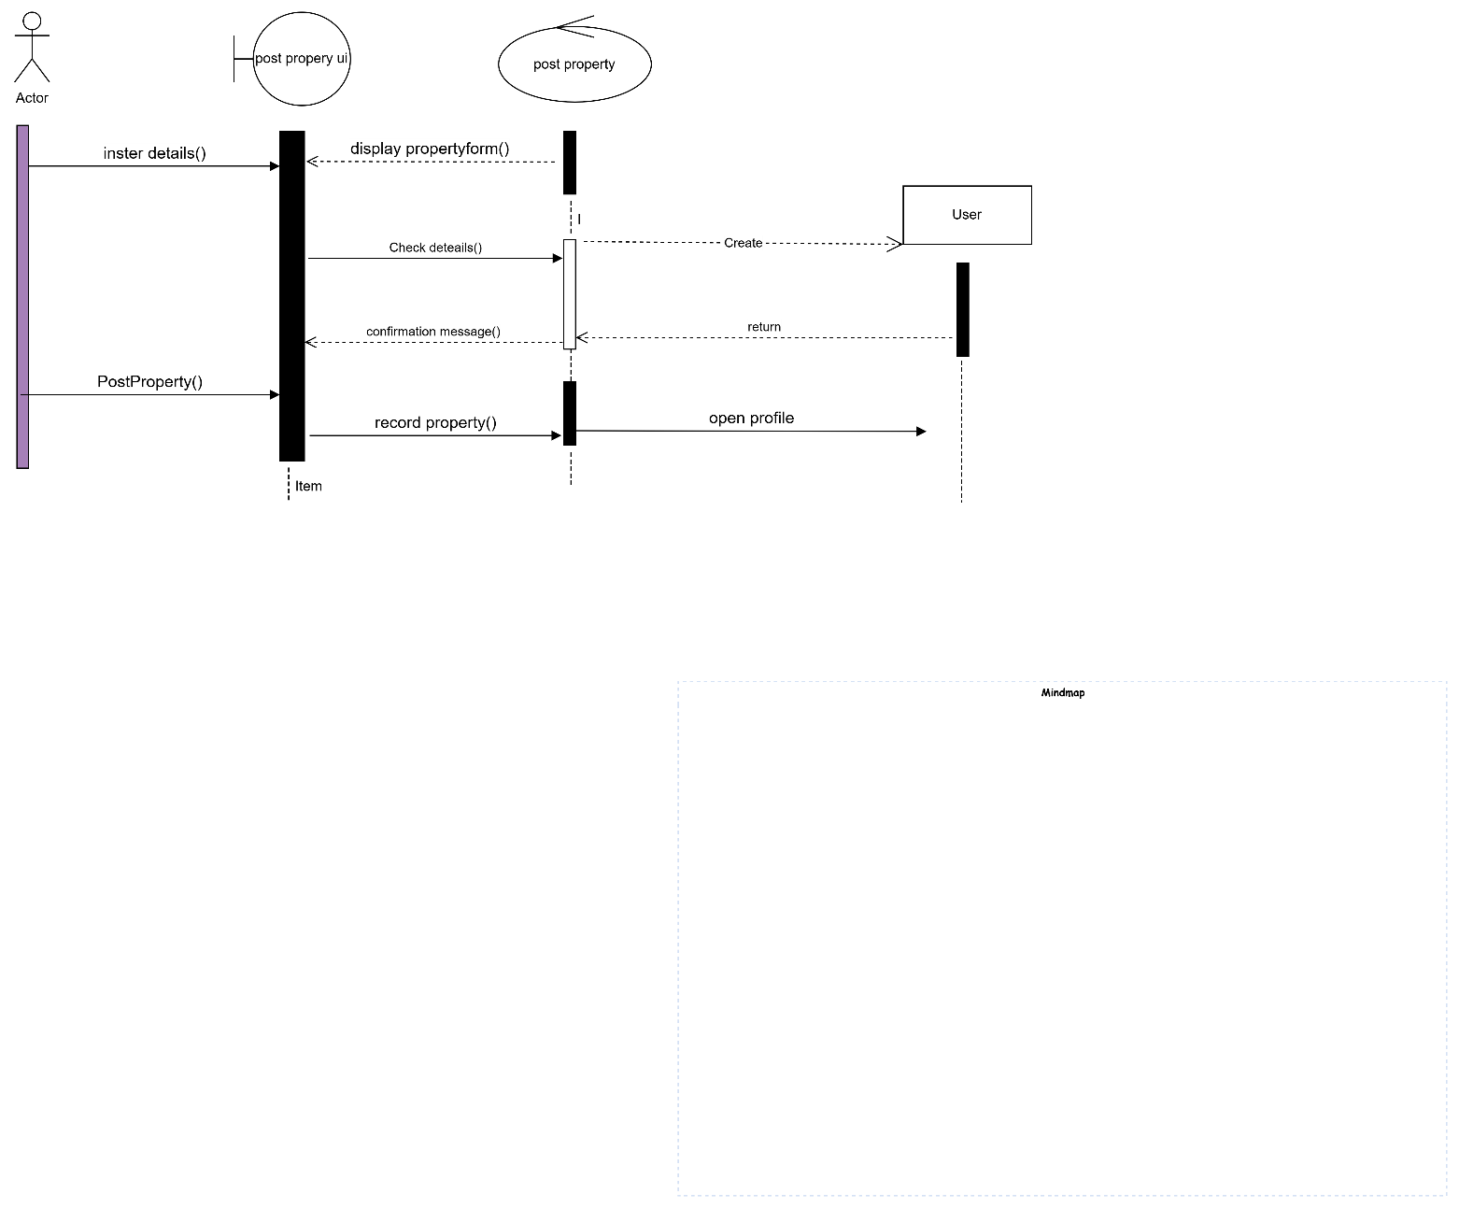

## Update Property

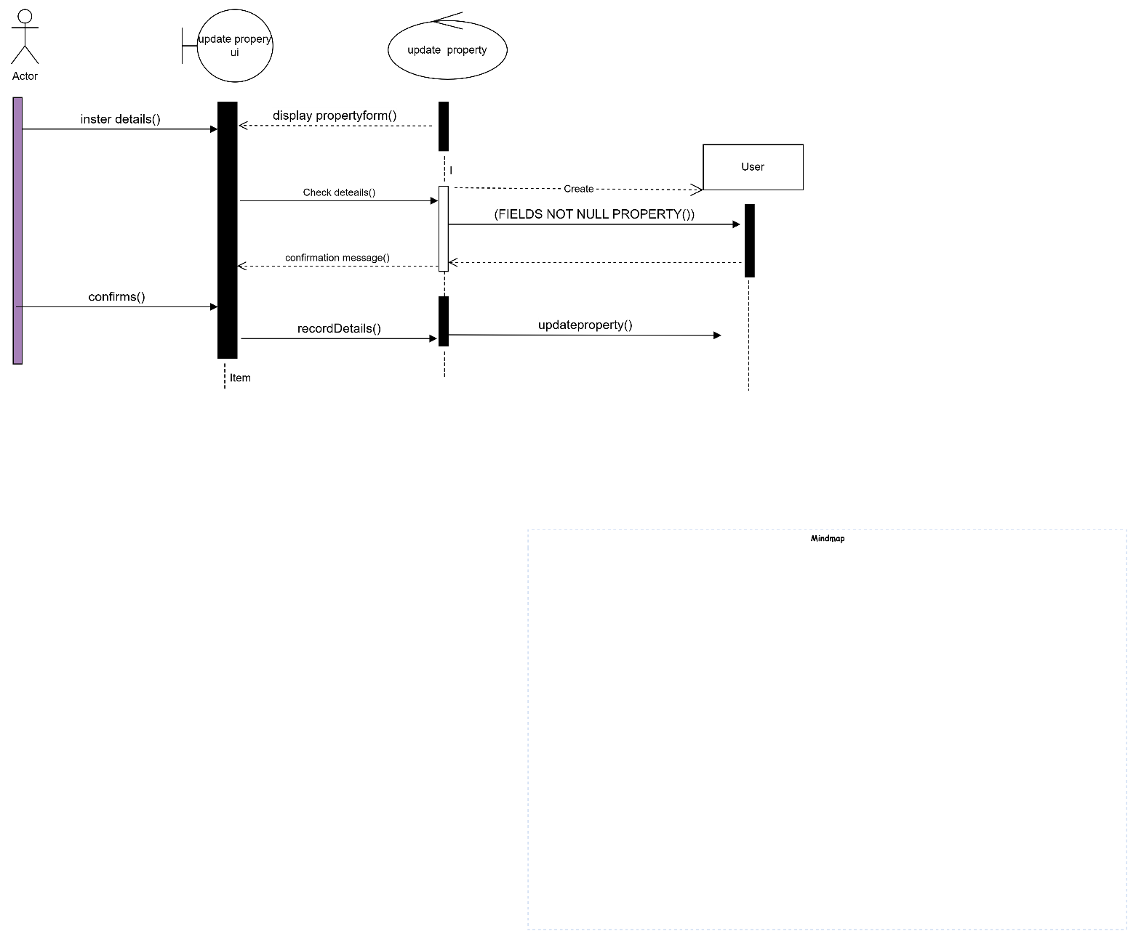

## Update profile

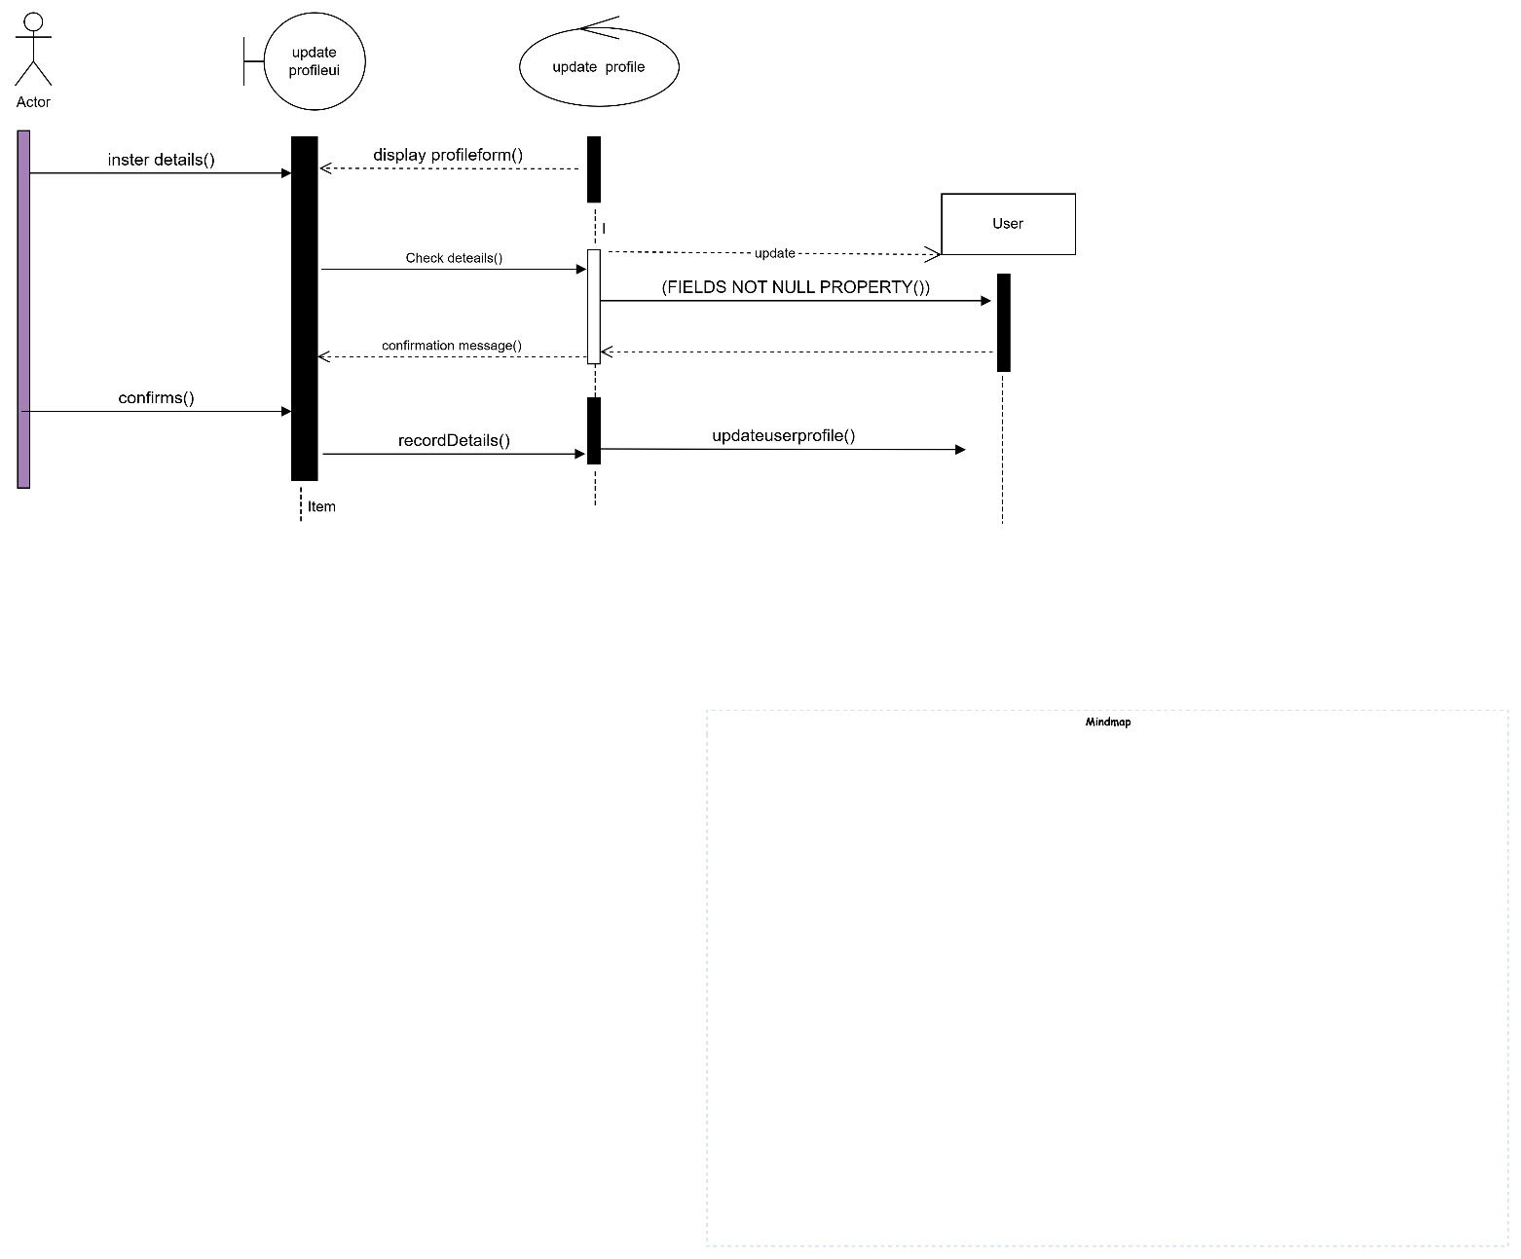

# Class Diagram

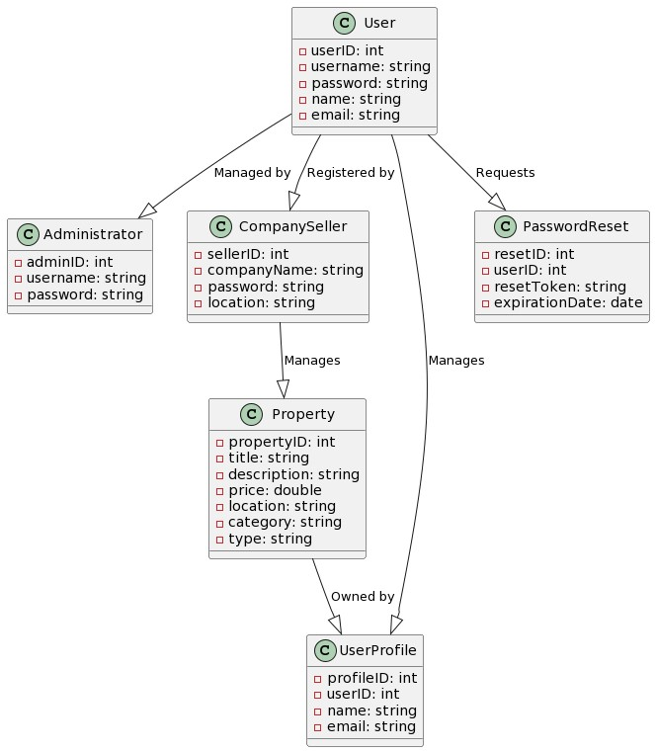

# Use Case Diagram

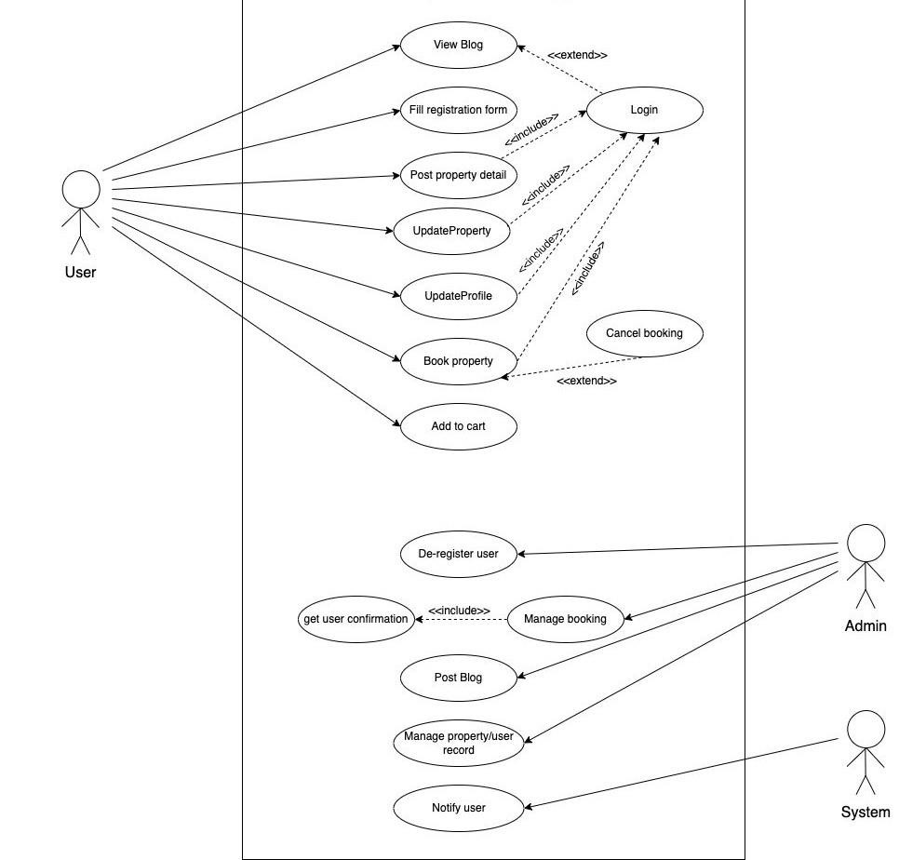

# Activity Diagram

